Committed to delivering a safe environment
www.safegolf.org
for golf

Is something worrying you?
Do you need someone to talk to? Speak to your club welfare officer
broadhurstgm@gmail.com
07725312979
Gill Broadhurst

Hello,
I’ve been a member at Bidston for over 6 years, having previously played golf from Prenton GC.
I worked in local government for 12 years before moving to LJMU. I was Head of International Recruitment before retiring, working across the globe in many different, diverse and exciting countries. Apart from the responsibility of being a friend and mentor to overseas students, their families, schools and colleagues I liaised with overseas Universities, future employers and the various Government bodies who had oversight for their entry and exit into the UK. I hope that my experience in many diverse areas can be helpful to Bidston GC and look forward to assisting if I can.
I’ve lived in Wirral for 40+ years but was born in Liverpool and still maintain I’m a scouser.
Happy to help, if you need to reach out.

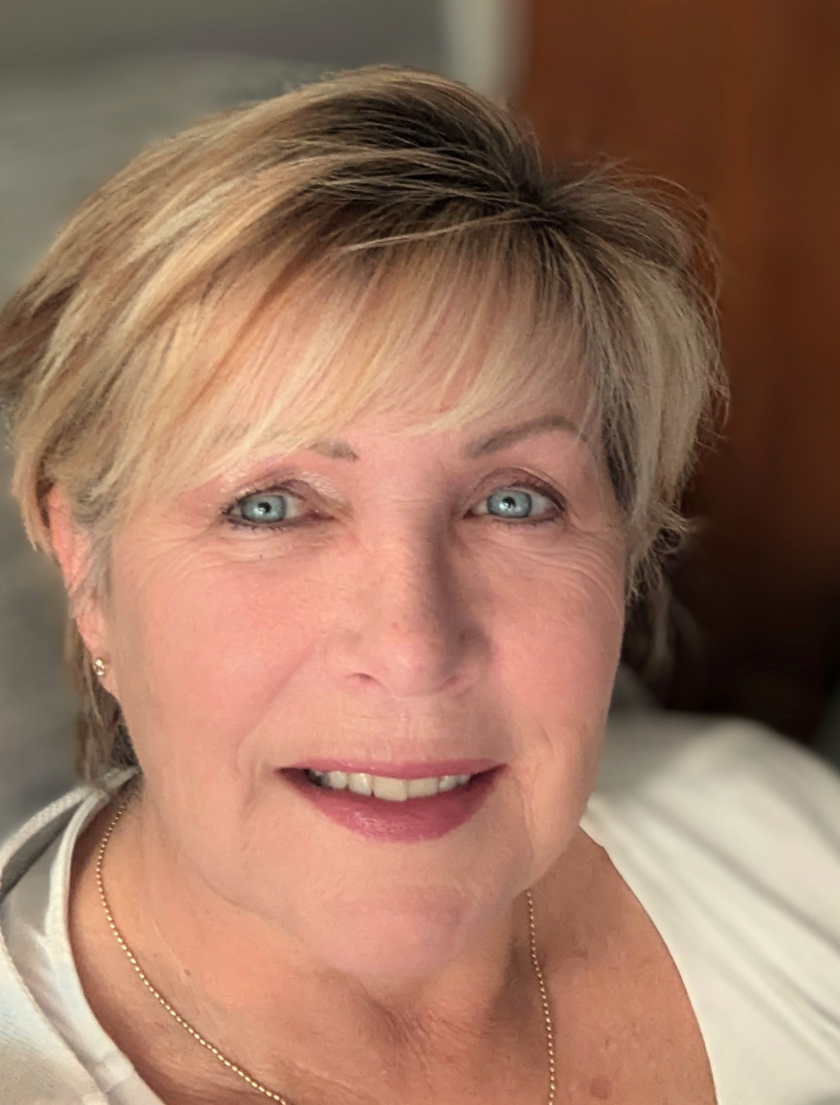

Alternatively, you can speak to someone at

ChildLine 0800 1111
NSPCC 0808 800 5000
England Golf 01526 351851

Club
WELFARE
officer

